NATIONAL UNIVERSITY OF MODERN LANGUAGE ISLAMABAD
Lab task:-02


Submitted to:
Mr. Meesam Raza
Submitted by:
Ehsaan Mehmood ()
Zulqarnain Hassan (SP21379)
Subject: …………………… Operating System
Department: ……………… BSSE-4-Afternoon
Date: ……………………… 15-03-2024

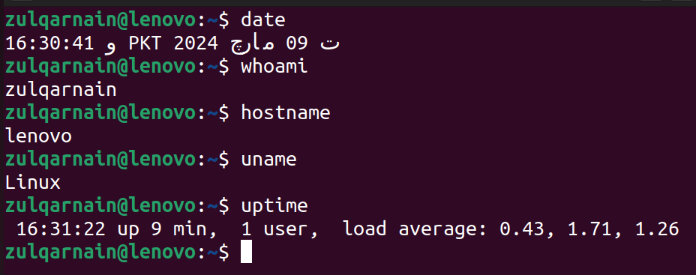
task:- 01

Task:- 02
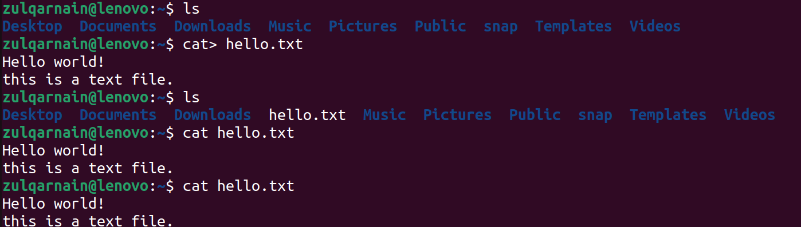

Task:- 03
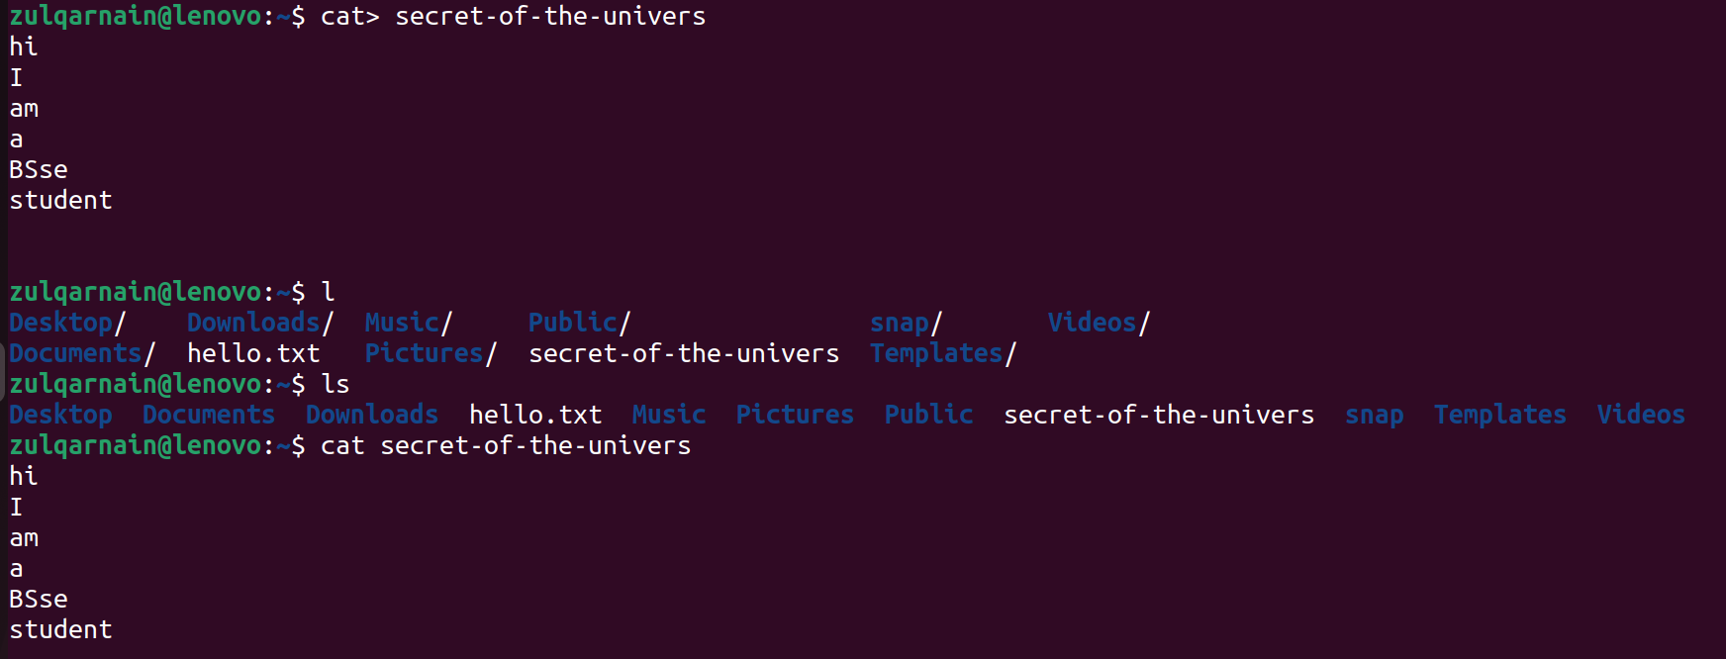

Task:- 04
